Supporting information 9: Validation of amplification efficiency of the second step PCR
A central assumption of this study is that the second-step PCR amplifies the products of all examined taxa with approximately equal efficiency, so that taxon-specific bias arises only in the first-step PCR. Because sequence-intrinsic properties such as GC content could also affect efficiency in the second step, this assumption was tested directly.
For this, a first-step PCR was performed for each of the DNA pools (Supporting information 2) with the fwh2 primers carrying the universal tails to generate amplicons identical to the products of the first-step PCR in the main experiment, including the universal binding sites. Cycling conditions were identical to the first-step PCR of the main experiment, but DNA was amplified for 40 cycles to obtain sufficient template for subsequent testing. Residual primers and primer dimers were removed with a bead-based cleanup (Buchner, 2022). This resulted in one first-step amplicon pool per taxon.
The amplicon pools were used as templates for a qPCR. The DNA concentration of each pool was measured with a Qubit fluorometer, and the pools were diluted in PCR-grade water to 10⁶ copies per reaction (calculated from the concentration and the amplicon length of 331 bp), so that all taxa were measured at the same template amount. qPCR was performed in 10 µL assays with 18 replicates per amplicon pool, using 1x PerfeCTa SYBR Green FastMix (Quantabio, Beverly, MA, USA), 100 nM of universal binding site primers identical to those used for the second PCR (forward universal tail: 5’-ACACTCTTTCCCTACACGACGCTCTTCCGATCT-3’, reverse universal tail: 5’-GTGACTGGAGTTCAGACGTGTGCTCTTCCGATCT-3’) but excluding the Illumina index and the P5/P7 adapter, 1 µL of diluted template and filled up to 10 µL with PCR-grade water. Six no-template controls were included in the qPCR measurement. qPCR was performed on a QuantStudio3 system (Thermo Fisher Scientific, Waltham, MA, USA). Thermal cycling was performed with 3 min of initial denaturation followed by 40 cycles of 15 s denaturation at 95 °C and 60 s of combined annealing and extension at 61 °C, which corresponds to the annealing temperature of the second PCR step in the main experiment. A melt curve analysis was performed after amplification (15 s at 95 °C, 60 s at 60 °C, then a continuous increase to 95 °C at 0.15 °C s⁻¹) to check that each reaction contained a single product. After the qPCR, the products of all wells were separated on a 1 % agarose gel to check the amplicon size.
qPCR raw data were exported (Supporting information 10) and further analyzed with the RDML-Python library (Untergasser et al., 2021). Peaks of the melt curves were identified in the smoothed derivative of the melt fluorescence (Savitzky-Golay filter, window of 7 points, polynomial order 2); peaks with a prominence of at least 5 % of the highest peak of the well were counted.
Per-well PCR efficiencies were estimated from the baseline-corrected fluorescence data with LinRegPCR (Ruijter et al., 2009) as implemented in RDML-Python (version 1.7.2), which determines the window of linearity for every well individually. Wells without a plateau, with an outlying efficiency or with an unstable baseline were excluded by the program; none of the 90 sample wells was excluded. E is given as the amplification factor per cycle (E = 2: perfect doubling). Efficiencies were compared between taxa with a Kruskal-Wallis test, which does not assume normally distributed residuals or equal variances, and epsilon squared (H / (N − 1)) is given as effect size.
The second-step PCR amplifies all five taxa with similar efficiencies (Figure 9.1, Table 9.1). Mean per-well efficiencies ranged from 1.808 (Blattodea) to 1.824 (Amphipoda), a difference of 0.016, and single wells ranged from 1.772 to 1.872. Efficiencies did not differ significantly between taxa (Kruskal-Wallis, H(4) = 8.2, p = 0.086, ε² = 0.09). Over the 25 to 39 cycles of the second PCR step in the main experiment, the difference between the taxa with the highest and the lowest mean efficiency would amount to a 1.25- to 1.41-fold difference in product.
Because all amplicon pools were measured at the same template amount, the quantification cycles (Cq) were similar between taxa (median 14.3 for Amphipoda to 14.9 for Diptera; all wells 14.0 to 15.4). All 90 sample wells showed a single melt peak (Figure 9.1C). The melting temperatures of the products were specific for each taxon (median 75.2 °C for Lepidoptera, 75.8 °C for Hymenoptera, 76.2 °C for Amphipoda, 77.3 °C for Blattodea and 78.3 °C for Diptera; Supporting information 10), whereas primer dimers would be expected to melt at the same, lower temperature in all reactions. In the no-template controls, one of six wells (E11) crossed the threshold at Cq 38.2, 23.5 cycles later than the median of the samples, with a melt peak at 77.0 °C; in two further wells (C6, H1) the fluorescence increased only in the last cycles (Cq above 40), and no amplification was detected in the remaining three wells. On the agarose gel, all sample wells showed a product of the same size, and no discrete product was visible in any of the six no-template controls.
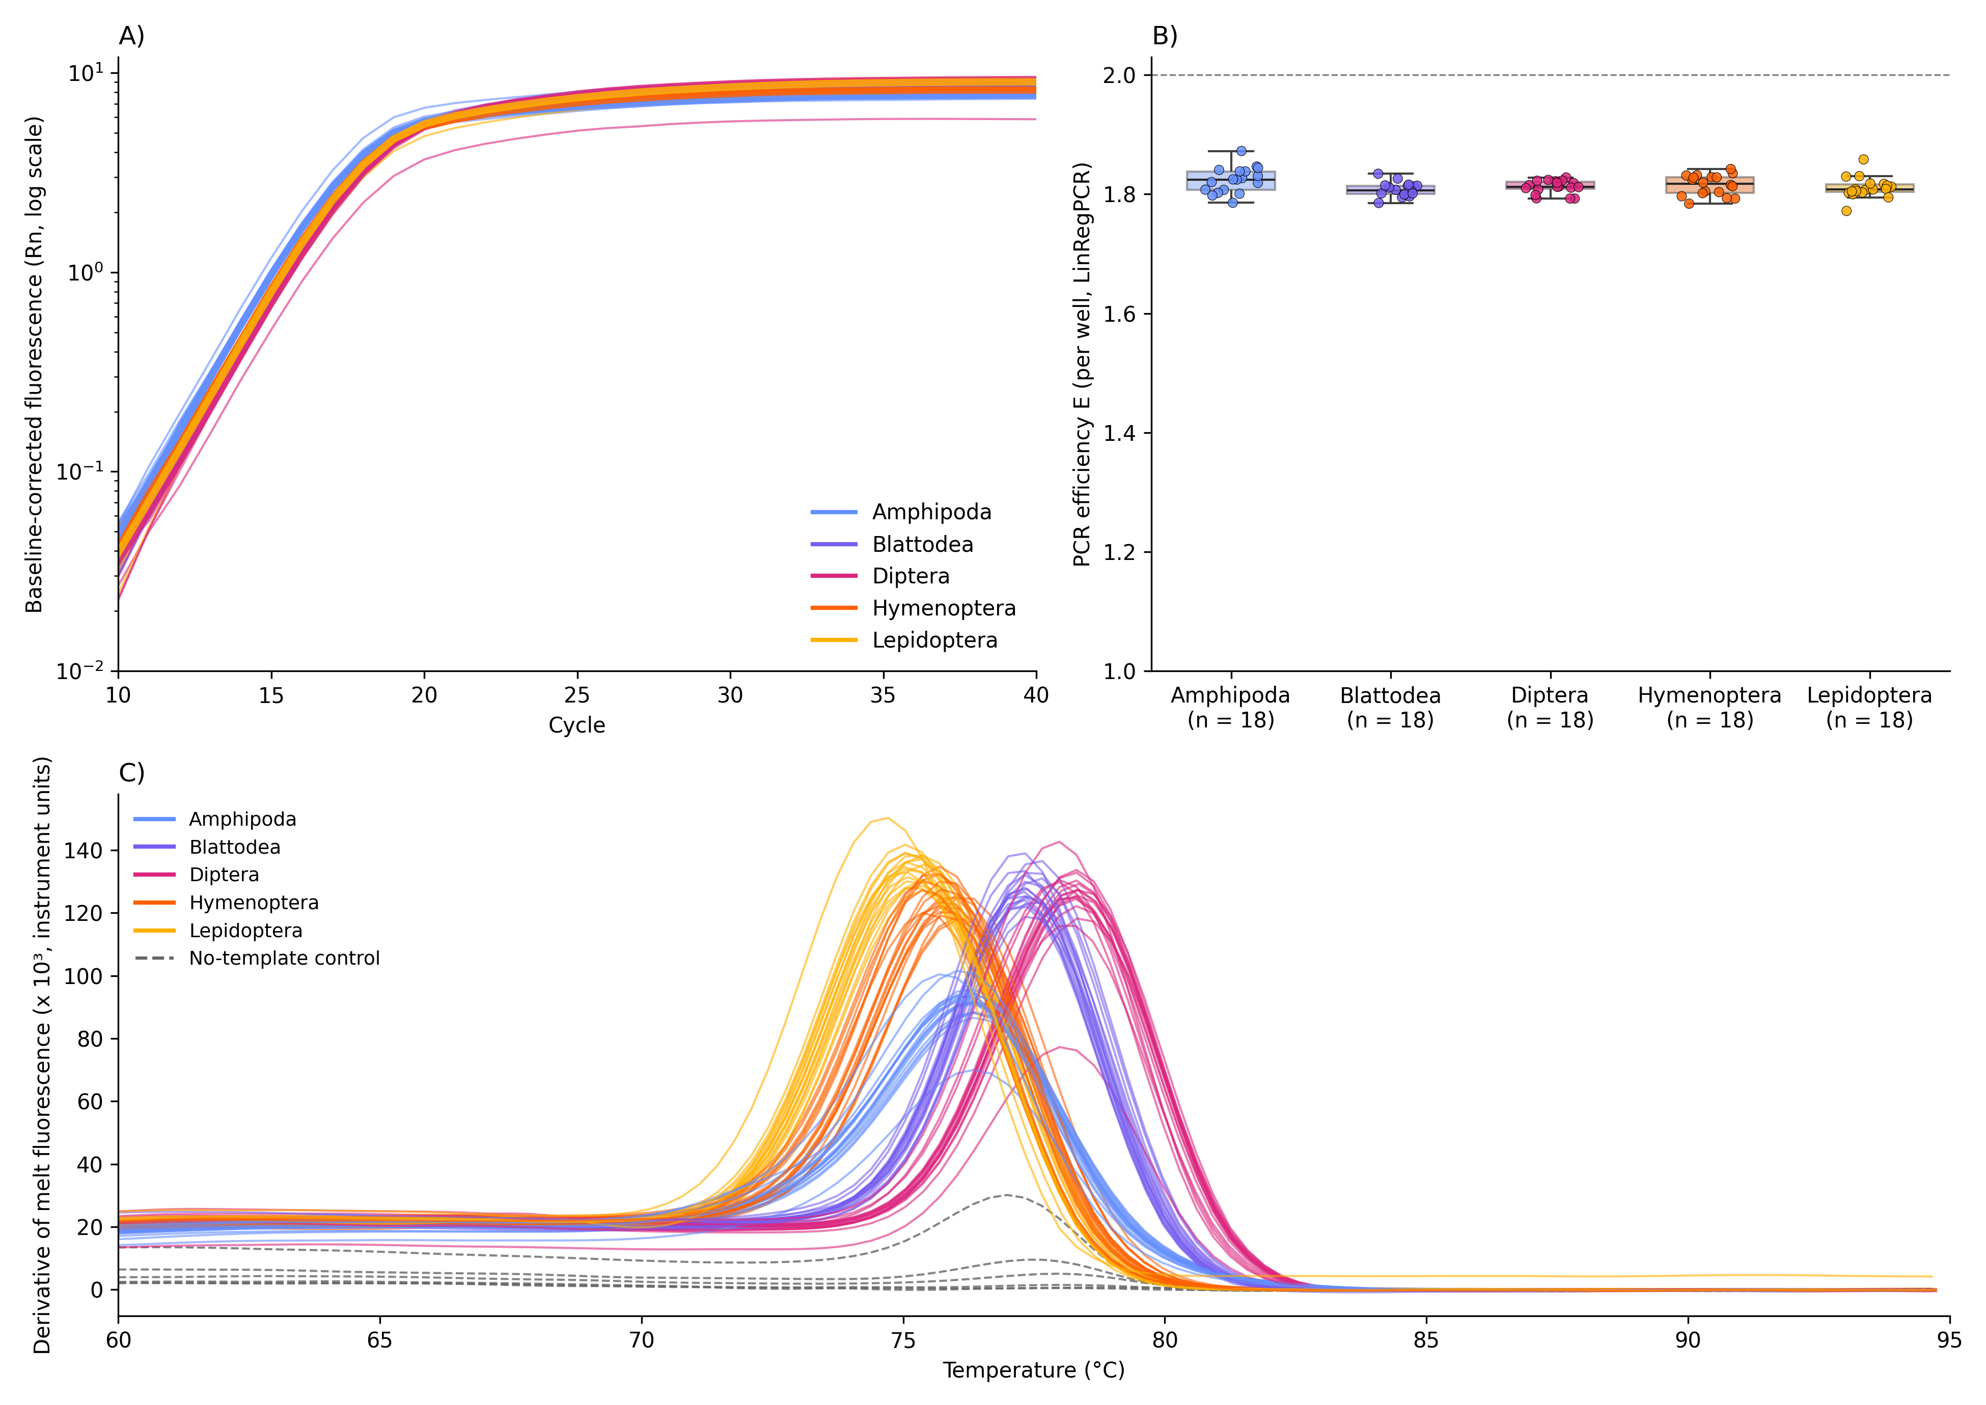
Figure 9.1: Efficiency of the second-step PCR across taxa. (A) Baseline-corrected amplification curves (thin lines: single wells; thick lines: median per taxon). (B) PCR efficiency E per well, estimated with LinRegPCR (box: median and interquartile range; whiskers: 1.5 × IQR; points: single wells). The dashed line marks E = 2 (perfect doubling per cycle). n = 18 wells per taxon. (C) Derivative of the melt curve of every well (coloured by taxon; dashed grey lines: no-template controls). All amplicon pools were measured at the same template amount (10⁶ copies per reaction).
Table 9.1: Mean, minimum and maximum PCR efficiency E per well of the second-step PCR for each taxon (n = 18 wells per taxon, estimated with LinRegPCR; E = 2: perfect doubling per cycle). Raw data and per-well values are given in Supporting information 10.
Taxon | Mean E | Min E | Max E
Amphipoda | 1.824 | 1.785 | 1.872
Blattodea | 1.808 | 1.785 | 1.834
Diptera | 1.812 | 1.793 | 1.828
Hymenoptera | 1.815 | 1.784 | 1.842
Lepidoptera | 1.811 | 1.772 | 1.858

References
Buchner, D. (2022). PCR cleanup and size selection with magnetic beads V.3. https://www.protocols.io/view/pcr-cleanup-and-size-selection-with-magnetic-beads-36wgqj45xvk5/v3
Ruijter, J. M., Ramakers, C., Hoogaars, W. M. H., Karlen, Y., Bakker, O., van den Hoff, M. J. B., & Moorman, A. F. M. (2009). Amplification efficiency: Linking baseline and bias in the analysis of quantitative PCR data. Nucleic Acids Research, 37(6), e45. https://doi.org/10.1093/nar/gkp045
Untergasser, A., Ruijter, J. M., Benes, V., & van den Hoff, M. J. B. (2021). Web-based LinRegPCR: Application for the visualization and analysis of (RT)-qPCR amplification and melting data. BMC Bioinformatics, 22, 398. https://doi.org/10.1186/s12859-021-04306-1

